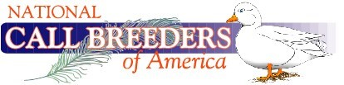

Open Show Report
(Jr. Show Report is also required)

Show Name:___________________________________________________ ABA Licensed___ APA Licensed____ NCBA Pre-Approved____
Show Secretary Name:__________________________________________ Judge Name__________________________________________________
Address:______________________________________________________ #of Calls Exhibited __________
Email or Phone:________________________________________________ #of Calls Exibitors___________
Show Date:____________________________________________________ use blank spaces for other varieties not listed below. Use back side of page if needed

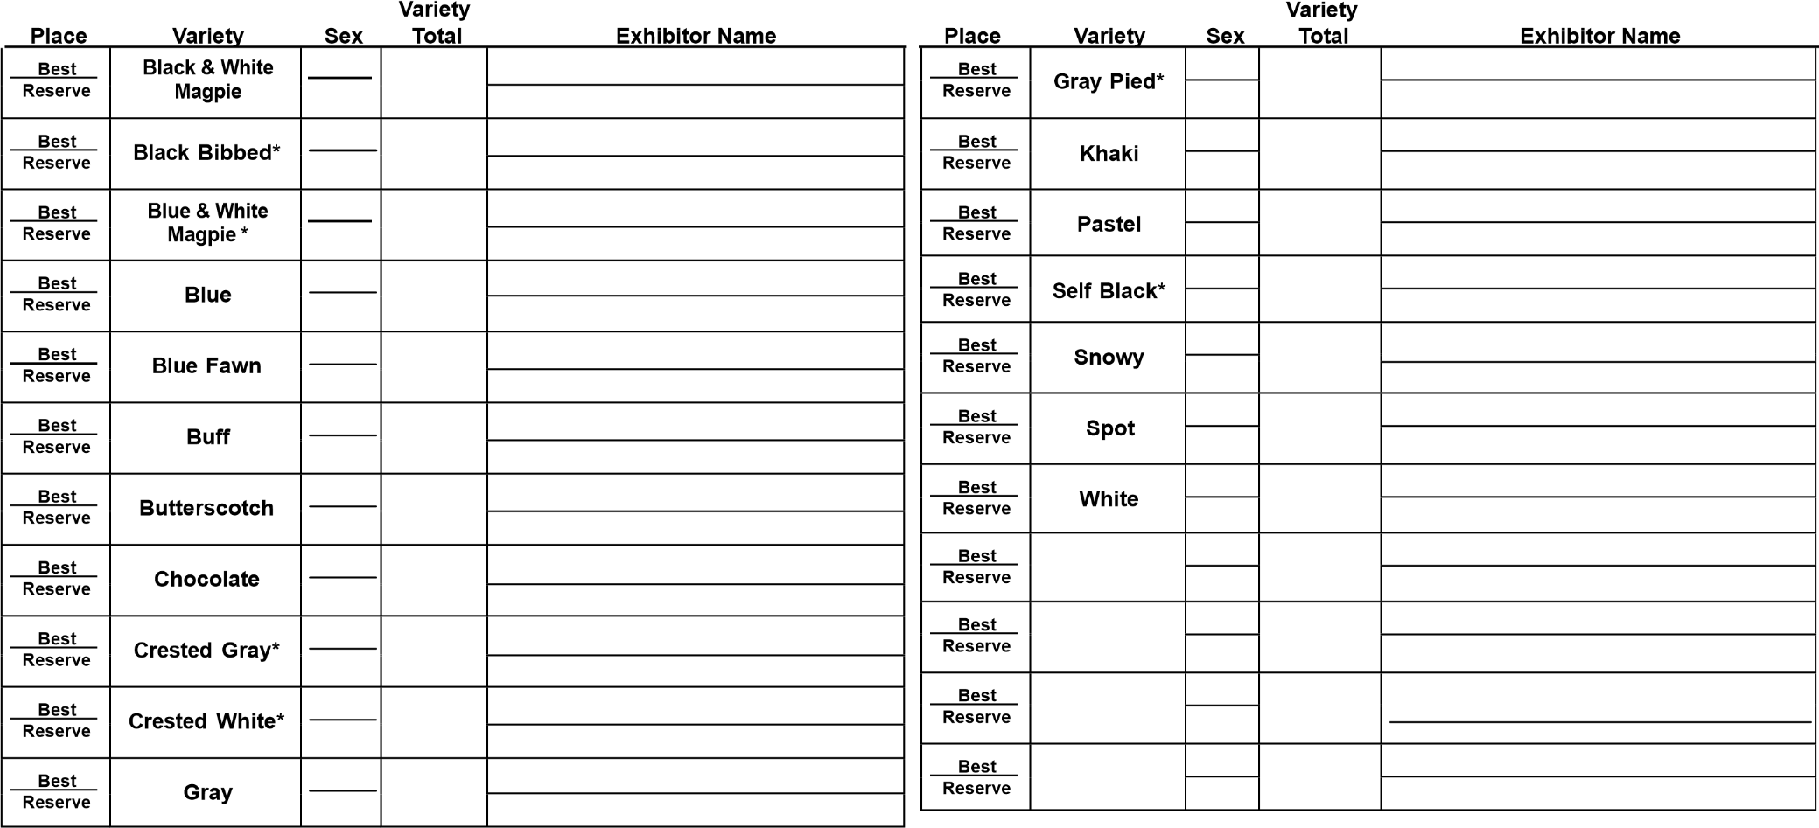

Return completed show report by email or US mail within 30 days of close of show. Please include an Exhibitor list.
Andy Chandler, N1468 Midway Rd, Hortonville, WI 54944
Please call or email questions to the NCBA Secretary
Andy Chandler (920)585-7964 or AndyChandler10@gmail.com

Best of Breed:________________________________________ Reserve of Breed:___________________________________________

Junior Show Report

Show Name:___________________________________________________ ABA Licensed___ APA Licensed____ NCBA Pre-Approved____
Show Secretary Name:__________________________________________ Judge Name__________________________________________________
Address:______________________________________________________ #of Calls Exhibited __________
Email or Phone:________________________________________________ #of Calls Exibitors___________
Show Date:____________________________________________________ use blank spaces for other varieties not listed below. Use back side of page if needed

Return completed show report by email or US mail within 30 days of close of show. Please include an Exhibitor list.
Andy Chandler, N1468 Midway Rd, Hortonville, WI 54944
Please call or email questions to the NCBA Secretary
Andy Chandler (920)585-7964 or AndyChandler10@gmail.com

Best of Breed:________________________________________ Reserve of Breed:___________________________________________

