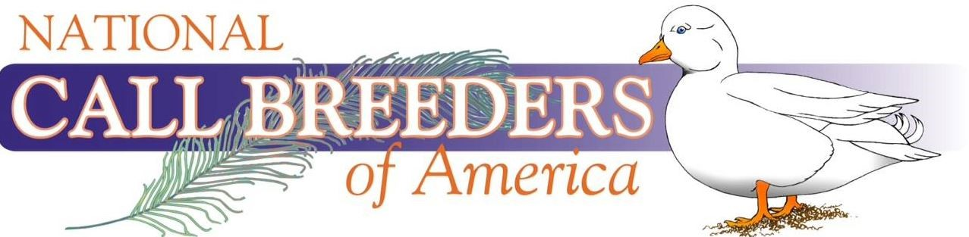
National Call Breeder’s National Show Bid

Name of show:______________________________________________________
Show Location:______________________________________________________
Date of Show: ______________________________________________________ Cooping: Single Deck __________ Double Deck __________ Other__________ Does the hosting show offer free space & tables for the National Meet? Yes ___
If Not, what is the charge __________
Does the hosting show offer the NCBA an entry rebate? Yes _____ No _____
If Yes, what is the rebate? __________
Will there be a meeting room available? Yes __________ No __________
Does the NCBA have the show’s consent to hold a raffle and sell Club Merchandise? Yes __________ No __________
Does the hosting show offer any special awards for hosting an NCBA National & if Yes, what are they? Yes _____________________________________ No ____
Will the hosting show offer the NCBA any choices regarding judges? Yes __ No __ If yes, what are those choices?__________________________________________ ___________________________________________________________________Signature of Club Officer ______________________________________________
Officer Phone Number ________________________ Date __________________

Please return to NCBA President: James Konecny 22172 N Hillview Dr. Barrington Hills, IL 60010

